Ideation Phase
Brainstorm & Idea Prioritization Template

Date | 31 January 2026
Team ID | LTVIP2026TMIDS66306
Project Name | Gemini historical artifact description
Maximum Marks | 4 marks

Brainstorming for “Gemini historical artifact description”:
Brainstorming for the project “Gemini Historical Artifact Description” focuses on exploring how artificial intelligence can help identify, analyze, and describe historical artifacts accurately. The main goal of this brainstorming session is to generate ideas on how Gemini can assist students, researchers, and museums in understanding the origin, cultural significance, and historical context of artifacts.
Gemini can solve this problem by using image analysis and natural language processing to examine artifact images and automatically generate detailed descriptions, including information about the artifact’s time period, material, origin, and cultural importance.
Step-1: Team Gathering, Collaboration and Select the Problem Statement:

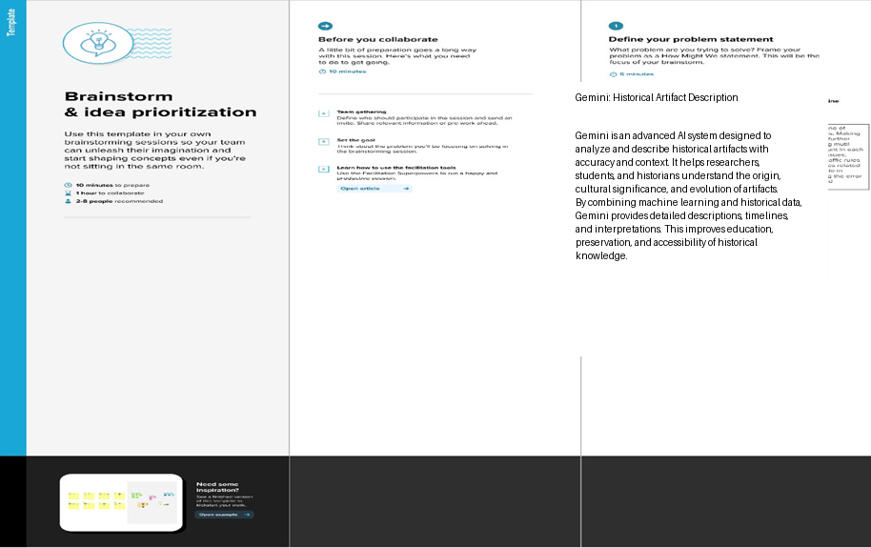

Step-2: Brainstorm, Idea Listing and grouping:

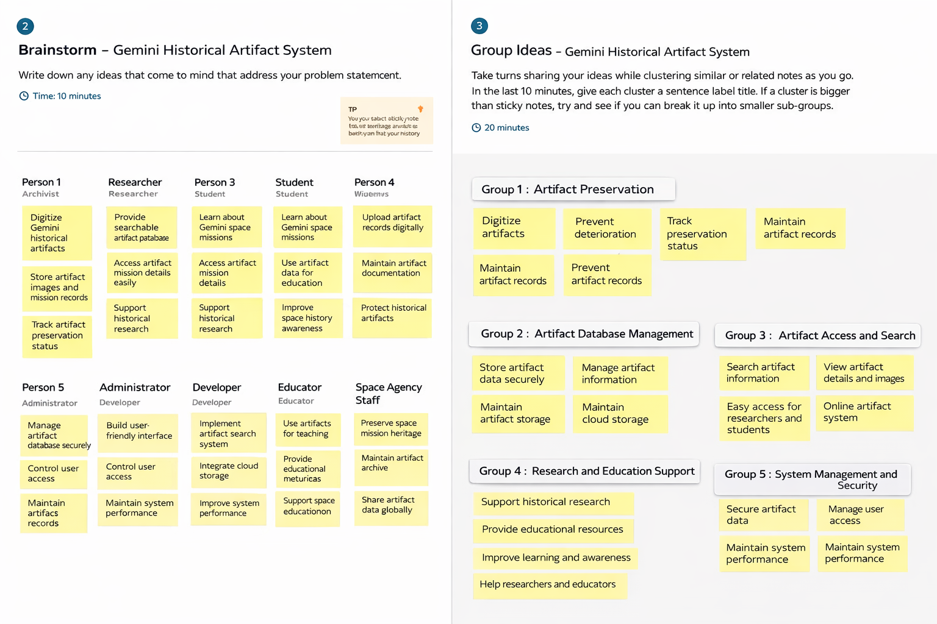
Step-3: Idea Prioritization

Idea prioritization for the Gemini Historical Artifact Description project focuses on selecting the most valuable and impactful features that improve artifact identification and understanding.

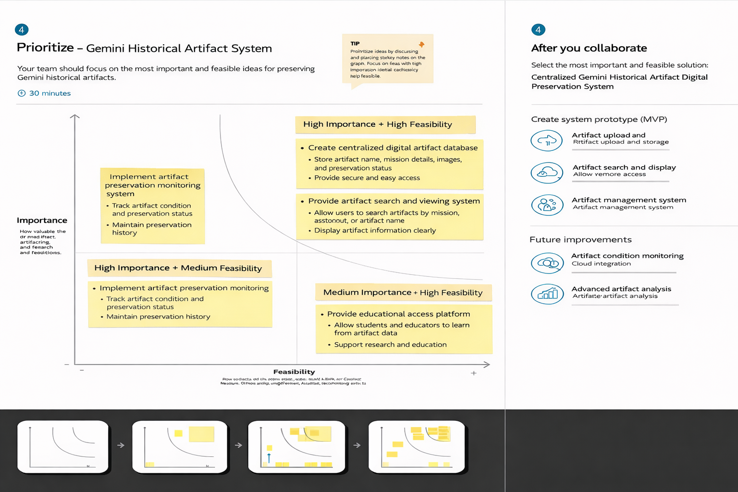
Here certainly we chose “Using Gemini Historical Artifact Description to analyze artifacts and generate accurate historical information” as our most prioritized idea. Among all other ideas, this was the most important to us because the main purpose of our project is to help users understand historical artifacts clearly and correctly. If Gemini does not provide accurate descriptions, then the information about the artifact’s origin, time period, material, and cultural significance may not be reliable. Therefore, ensuring that Gemini can properly analyze and describe historical artifacts is our top priority.

Then comes our second most important idea, which is “Collaborating with museums, historians, and cultural organizations to use Gemini Historical Artifact Description for artifact documentation.” This was taken as our second priority because it helps preserve cultural heritage and supports social responsibility. By working with museums and organizations, Gemini can help digitally document artifacts and make historical knowledge more accessible to students, researchers, and the public.

Then comes our next idea, which is “Providing additional features such as multilingual descriptions, artifact comparison, and digital catalog support using Gemini Historical Artifact Description.” After achieving our main goal, we will expand the system to include these advanced features. This will make the project more useful by helping users understand artifacts in different languages, compare similar artifacts, and maintain organized digital records. This will increase the overall value and effectiveness of the Gemini Historical Artifact Description project.

